Bundle formation of supramolecular fibers of amphiphilic diarylethene by depletion force and photoinduced submillimeter-scale shrinking

Kenji Matsuda

Department of Synthetic Chemistry and Biological Chemistry, Graduate School of Engineering,
Kyoto University, Katsura, Nishikyo-ku, Kyoto 615-8510, Japan
Email: kmatsuda@sbchem.kyoto-u.ac.jp

In order to apply photochromic diarylethene in practical use, especially in molecular electronics, assembly and arrangement of the molecules are very important. Therefore, supramolecular chemistry in two- and three dimensional assemblies is attracting interest.
Self-assembled microstructures of an amphiphilic diarylethene showed a photoinduced reversible morphological change in water [1-5]. Photoisomerization of the core diarylethene gave rise to a morphological transformation between colorless microspheres and colored fibers. This system showed reversible morphological change also by temperature change. These behaviors can be interpreted as a photoinduced LCST transition (Figure 1a-d).
Supramolecular nanofibers composed of the closed-ring isomer formed bundles in methylcellulose aqueous solution by depletion force while the spheres composed of the open-ring isomer were not coagulated [6]. Upon irradiation with UV light to the suspension of the open-ring isomer, the fibers were found to be generated and the formed submillimeter-sized bundles showed photoinduced shrinking over than 100 μm by the visible light irradiation (Figure 1e).
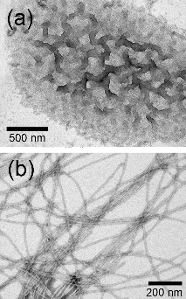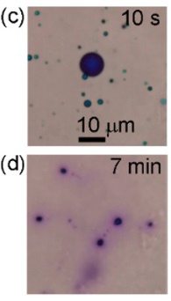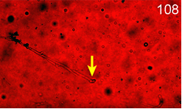
(e)
Figure 1. Sphere-fiber phase transition of diarylethene 1: TEM image of (a) open-ring isomer 1a, (b) closed-ring isomer 1b; optical microscope image (c) immediately after UV irradiation and (d) after 7 min of UV irradiation; (e) shrinking of a long bundle upon irradiation with visible light for 108 s.

[1] K. Higashiguchi, G. Taira, J.-i. Kitai, T. Hirose, K. Matsuda, J. Am. Chem. Soc. 2015, 137, 2722.
[2] A. Sakaguchi, K. Higashiguchi, H. Yotsuji, K. Matsuda, J. Phys. Chem. B 2017, 121, 4265.
[3] H. Yotsuji, K. Higashiguchi, R. Sato, Y. Shigeta, K. Matsuda, Chem. Eur. J. 2017, 23, 15059. (inside cover)
[4] A. Sakaguchi, K. Higashiguchi, K. Matsuda, ChemPhotoChem 2017, 1, 488. (front cover)
[5] K. Higashiguchi, H. Yotsuji, K. Matsuda, Chem. Lett. 2017, 46, 1564.
[6] A. Sakaguchi, K. Higashiguchi, K. Matsuda, Chem. Commun. 2018, 54, 4298.
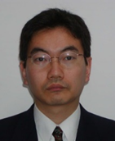 | Kenji Matsuda (松田建児), U of Tokyo (B.S. 1992; M.S. 1994, Ph. D. 1997), Assist. Prof., U of Tokyo (1994-1995), Assist. and Assoc. Profs., Kyushu U (1995-2008), Visiting Scholar, U of Illinois at Urbana-Champaign (2001-2002), Professor, Kyoto U (since 2008). Research interests: physical organic chemistry in a broad sense. The corner stone of our scientific philosophy is that we would like to design an ideal experimental system that envisions a revolutionary scientific concept.

